1)

Home Page: When a user logs in his is brought to this page

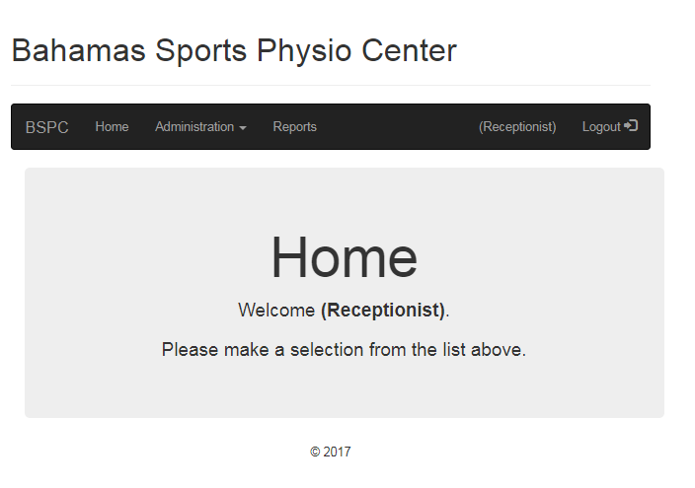

Registration Page: This is the page where the receptionist can register a user(patient/employee) to the system. We can also register an employee into the system.

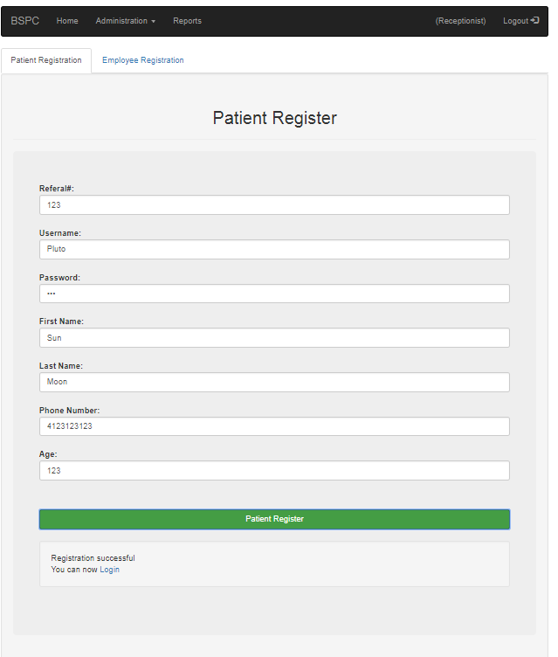

Login Page: This is the page that is presented to the user when they try to access our system.

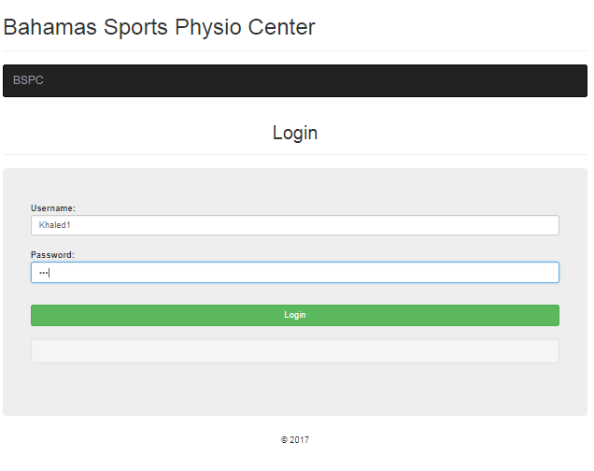

Appointment Page: This is the page where a receptionist books an appointment for a user. There is a tab for booking an appointment with the doctor and another one for booking an appointment with a therapist. They both look the same. An appointment cannot be booked from a past date and it to be booked 8 weeks prior to the appointment date. We consider 8 weeks to be 56 days.

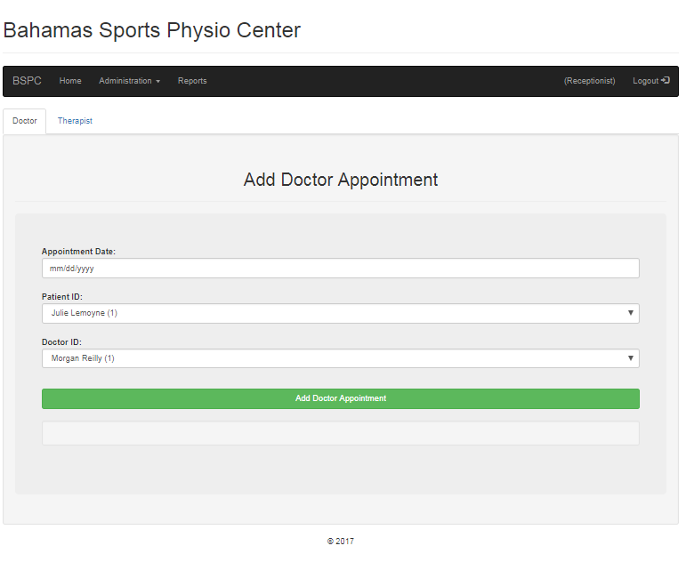

Patients page: This is the page that shows all the relevant information about patients.

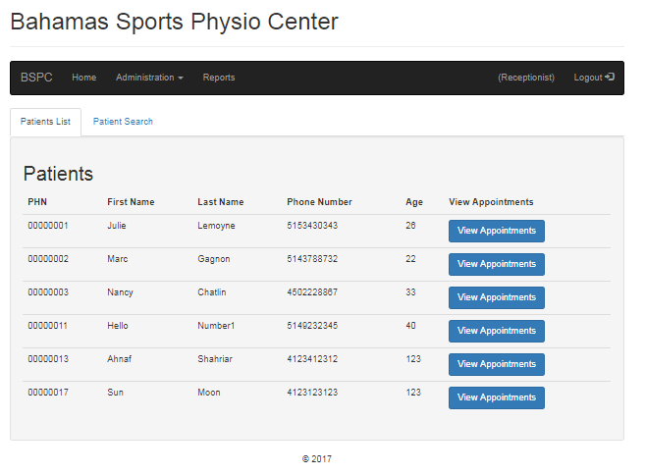

There is also a button that allows you to view the appointments of a specific patient. When that button is clicked it brings you to another page that allows you to see the doctor/therapist appointments that a patient has booked.

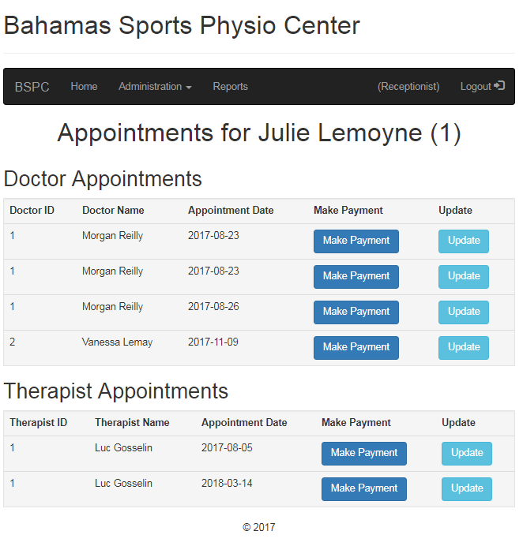

The make payment button allows the receptionist to perform a payment on behalf of a user.

Update appointment page: This is the page that enables a receptionist to reschedule a user’s appointment with a doctor or a therapist.

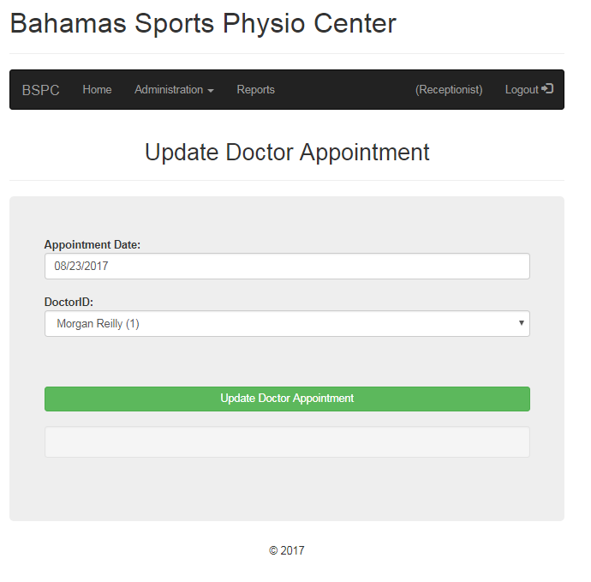

Staff page: This page allows to display the names and IDs of all doctors and therapists.

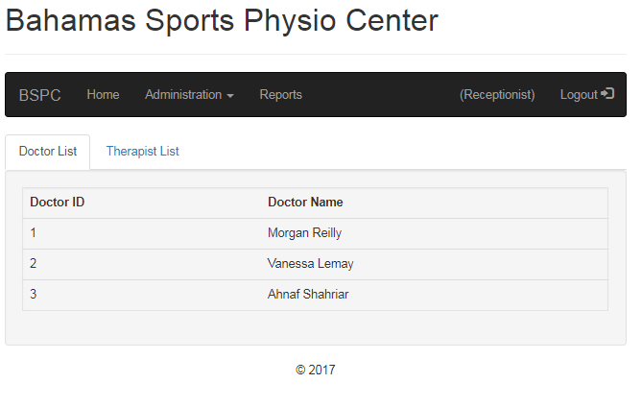

Reports: This page displays the number of patients that per therapist between a time lapse. We can also display information about equipment that were never used till today. There is also the possibility to display the list of patients and therapist that have visited the center. There is also the possibility to display the list of therapists that currently work at the center. A receptionist also has the ability to display the reservations made by a patient. The last option that is available on this page is to display doctor and therapist availabilities.

